Scoring System

For

Tae Kwon Do

Base Unit

Score and Time Display

Match Reset

Battery Power

Off / On (if used)

Match End Beeper

Timer Start/Stop

Number of Judges

Multiple or 1

Power and Comm

Cord

Cord\\\

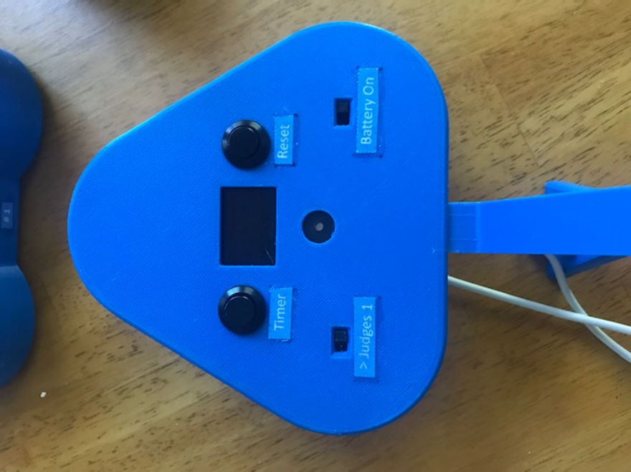

Controller

Indicator Light

Blue 2-pt Score

Red 2-pt Score

Red 1-pt Score

Blue 1-pt Score

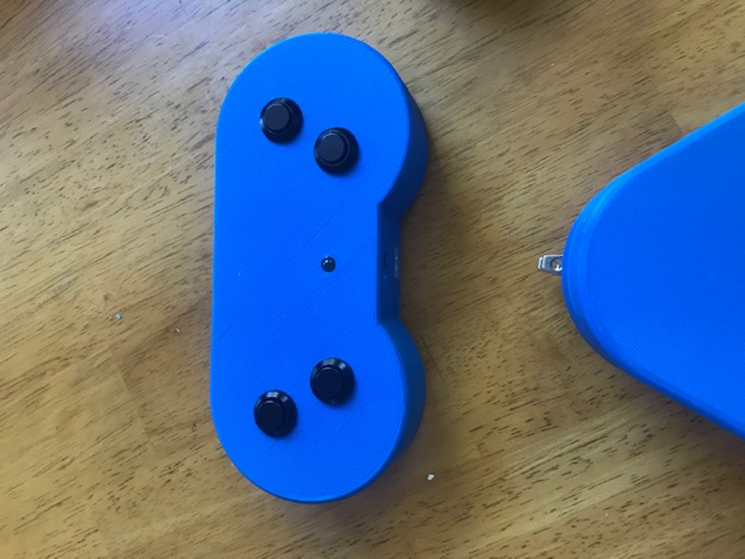

Power On/Off

Base Unit

The Base Unit is the center of the system. It can be connected to a computer USB for power, it can be connected to a USB supply if no computer is available, or it can be battery powered by 3 - AAA batteries. (do not use batteries when other supplies are connected).

When connected to a computer running the “TaeKwonDo” application the computer display will mimic the Base Unit Display.

Start-up:



Connect the Base Unit to power. It will start with the display showing a banner saying:

Blue Red

0 – 0 score and

2:00 minutes on the timer.

Operation:

Pressing the “Reset“ button will return the Unit to its state at any time.

Pressing the “Timer” button will start or stop the match timer

Sliding the “Judges” switch to the “1” side will allow a single judge to record scores.

Sliding the “Judges” switch to the “>” side will require at least a second judge’s confirmation to record a score.

The Battery On switch is used in stand-alone battery mode and should not be toward the “On” position when using other power sources through the USB cable.

Controllers



A Controller is the judge’s interface to the system. It is battery powered by 3 - AAA batteries.

Start-up:

Slide the On/Off switch on the bottom to the “On” position.

If a Base Unit is not present, the “Indicator” light will blink 3 times in rapid succession to show that no communication with the base is established,

When a Base Unit communication present and powered-up, the “Indicator” light will blink every half-second (a heartbeat transmission to the Base Unit) or whenever a Score button is pressed (to show a score message was transmitted).

Operation:

Pressing one of the score buttons will send a message to the Base Unit. Only one button may be pressed at a time.

The two buttons to the left are to enter scores for the Blue team and the two buttons to the right are for the Red team.

The judge will press with of the buttons nearer the top will score 2-points as needed to score “Head” contact for the appropriate team, or he will press the either of the lower buttons to score 1-point as needed to indicate “Body” contact for the team.

Computer User Interface Display

Connect the “Base Unit” to the computer. Start the Tae Kwon Do application.

Most of this display of obvious. The Score and the Time in the boxes will mimic the scores and Time shown on the Base Unit.

The columns of data at the bottom will show the total data collected by each of the controller units at the end of each match. (if additional analysis is necessary at the end of a match)

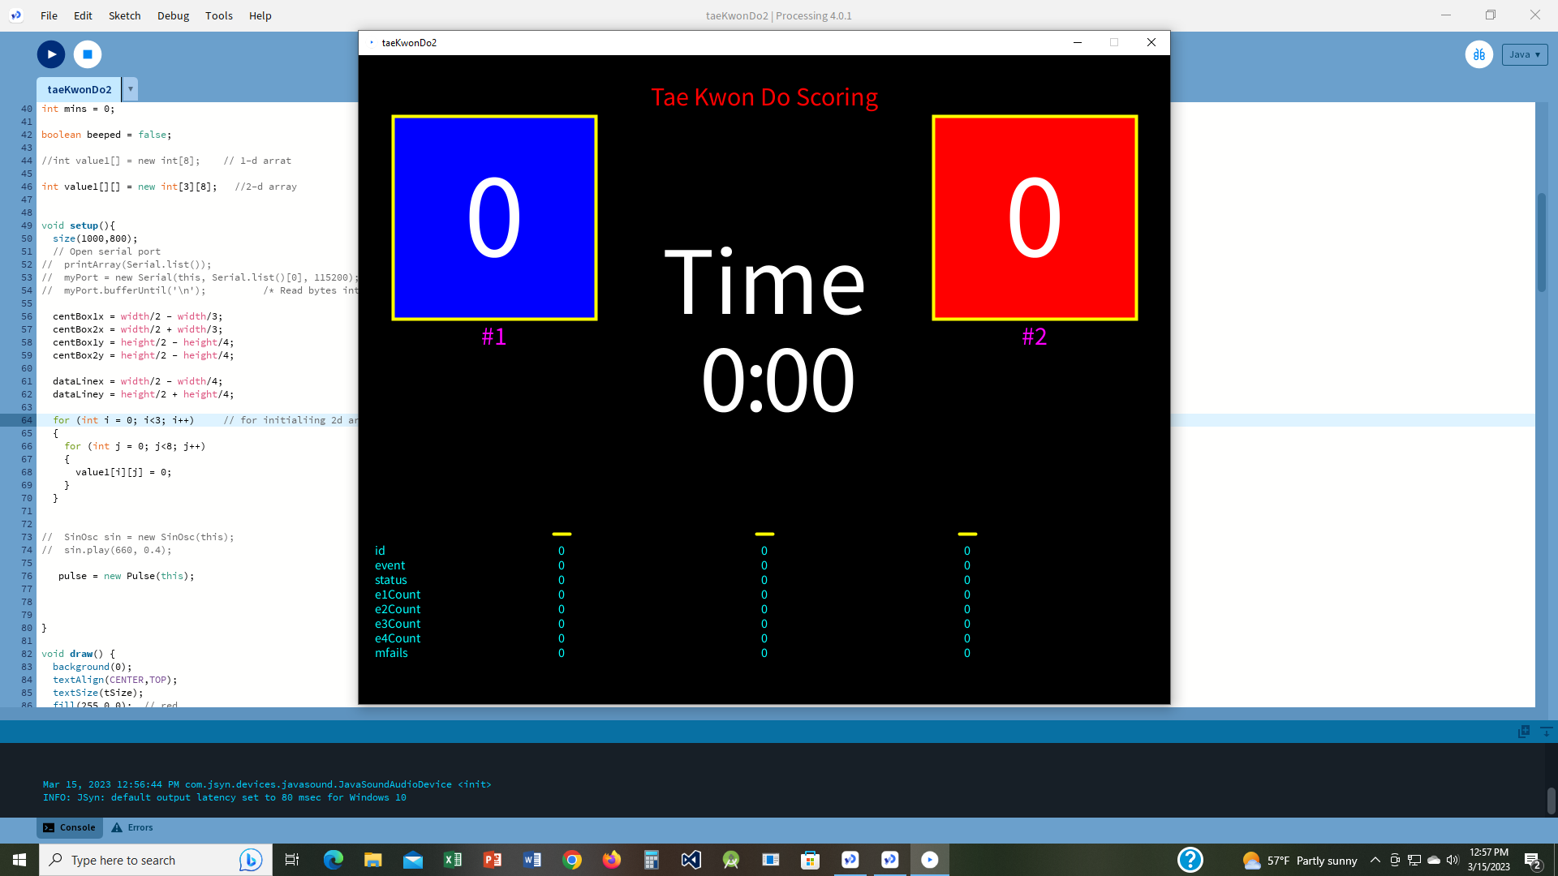

Computer UI Operation:

Operational features available on the Base Unit are also available on the computer interface and a few added features are available, as well.

Before a match begins, these features should be tested to verify connectivity to the Base Unit. The application may need to be re-started fi connectivity is not established at first

Control of the match can be run for the Computer UI

UI Controls added features:

A lowercase ‘r’ is the same as the “Match Reset” button on the Base unit. It will reset scores to “0” and Match Timer to the beginning time of the match (2 minutes by default).

A lowercase ‘t’ is the same as the “Timer Start/Stop” button on the Base unit. It can be used to control the Match Timer pausing or restarting the timer as required.

The ‘1’ key can be used at add an extra point to the Blue team’s score. If required. And the ‘2’ key subtracts 1 from Blue’s score.

The ‘0’ key can be used at add an extra point to the Blue team’s score. If required. And the ‘9’ key subtracts 1 from Red’s score.

A lowercase ‘z’ can be used to provide for longer matches, if desired. The ‘m’ will increase the match time by 1 minute. The Match Timer will show the “new time length” when the reset function is performed either from the Base Unit or the Computer interface.

A lowercase ‘x’ can be used to provide for shorted matches, if desired. The ‘x’ will decrease the match time by 1 minute (to a minimum of 1 minute). The Match Timer will show the “new time length” when the reset function is performed either from the Base Unit or the Computer interface.

A lowercase ‘l’ (L) adds an extra 10ms to the default 250ms EventWindow time. The EventWindow time is the amount of time that a second judge has to conform a score after the first judge entry. It is also window in which another score cannot be recorded.

A lowercase ‘k’ subtracts 10ms from the Event Window time. If the controllers seems sluggish and/or is preventing rapid scoring during match play, it might be that the EventWindow time is too long.

A lowercase ‘d’ will dump all of the extra controller data. (Only visible if using taeKwonDo1 user application)

The little lines/boxes above the controller statistics will show if the individual controllers have a valid communication channel. The boxes will be “green” of the channel is good. The boxes will be “red” if the communication channel to that control has failed.